Lab Exam:01
Title: Association/Classification/Fact and Dimension Table

Course title: Data Mining Problem Description

Course code: CSE-452
4th Year 1st Semester Examination 2025

Date of Submission: 23/April/2026

Submitted to-

Md. Humayun Kabir
Professor
Department of Computer Science and Engineering
Jahangirnagar University

&

Dr. Md Musfique Anwar
Professor
Department of Computer Science and Engineering
Jahangirnagar University
Savar, Dhaka-1342

Class Roll | Exam Roll | Name
395 | 210915 | Tawhidul Islam

- Classification On my project dataset “Intelligence Automatic Supervisor Allocation System ”

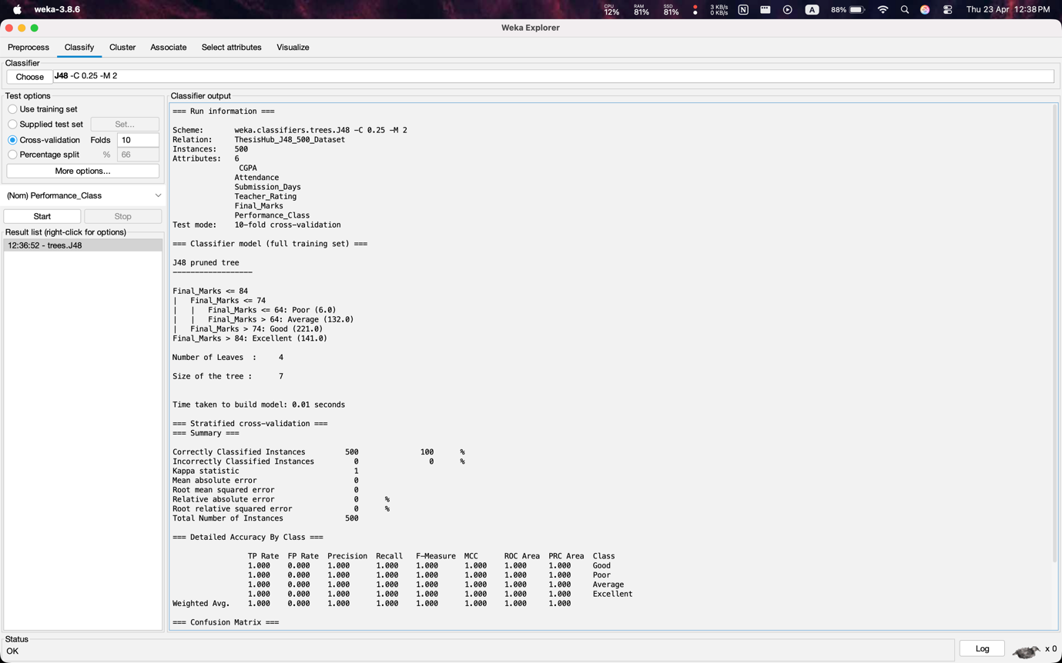

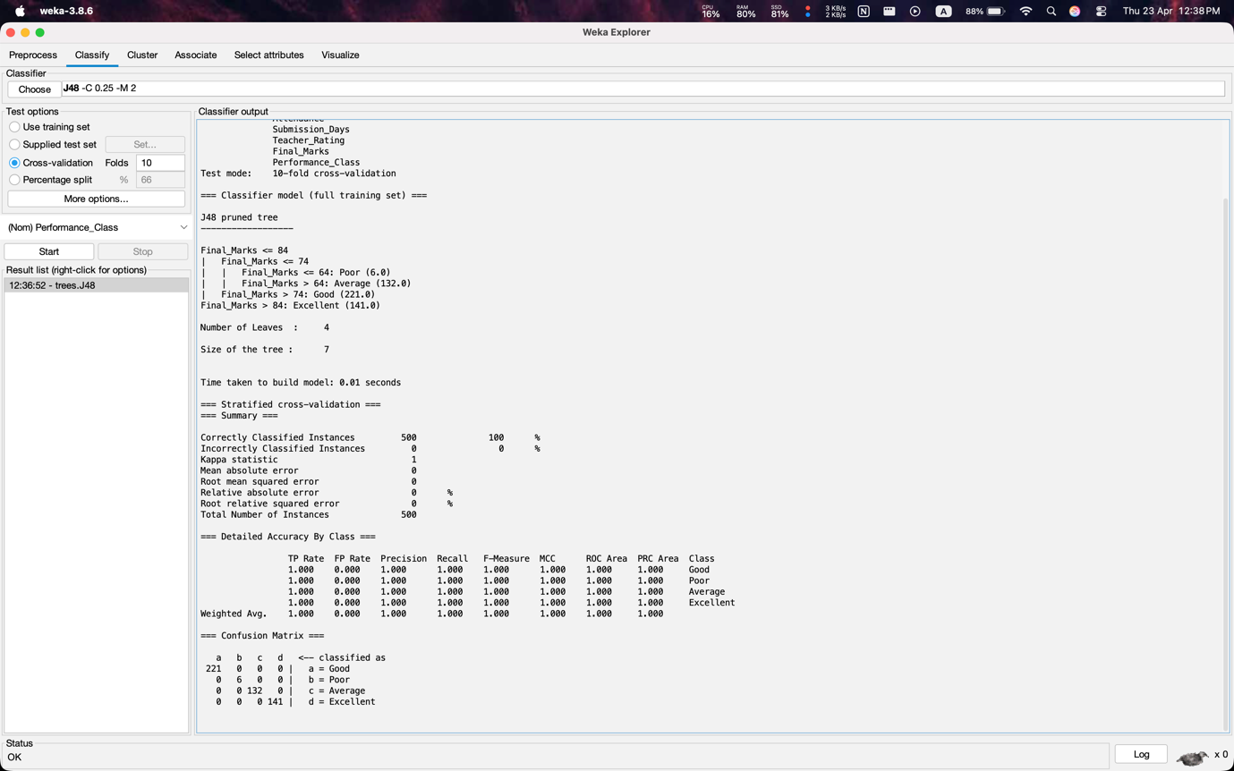

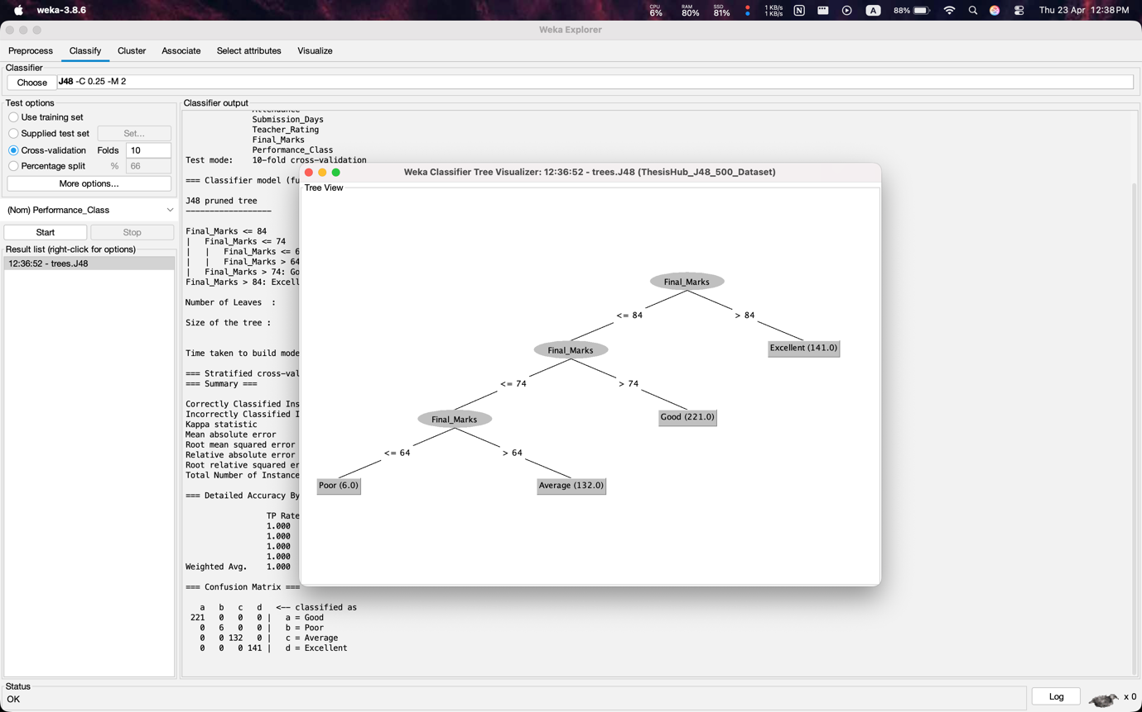

- Association Rule On my project dataset “Intelligence Automatic Supervisor Allocation System”

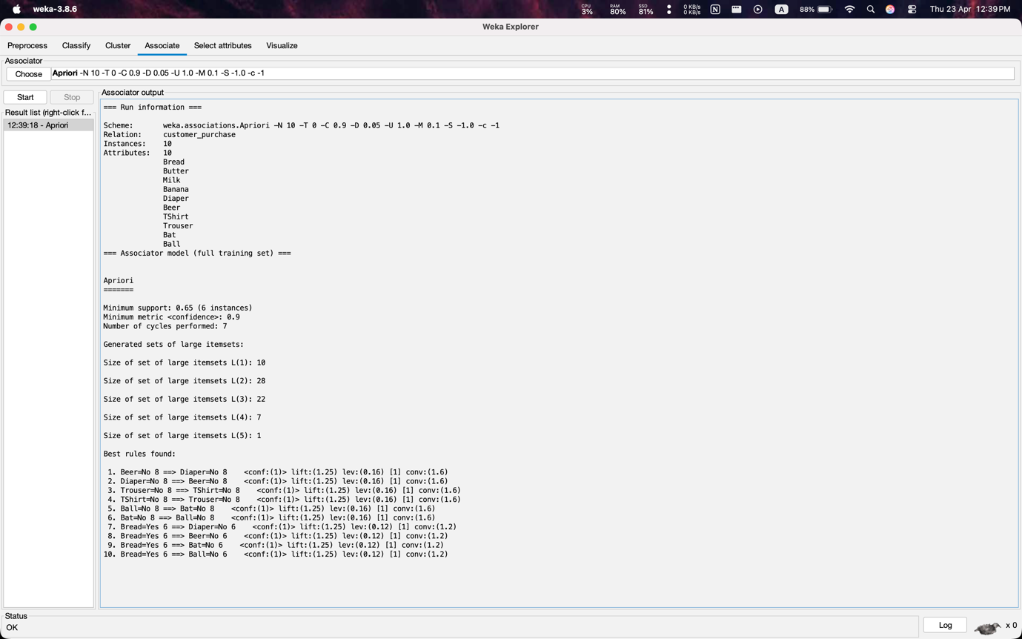

- Design Fact Table and Dimension Table

Fact Table:
- Creation
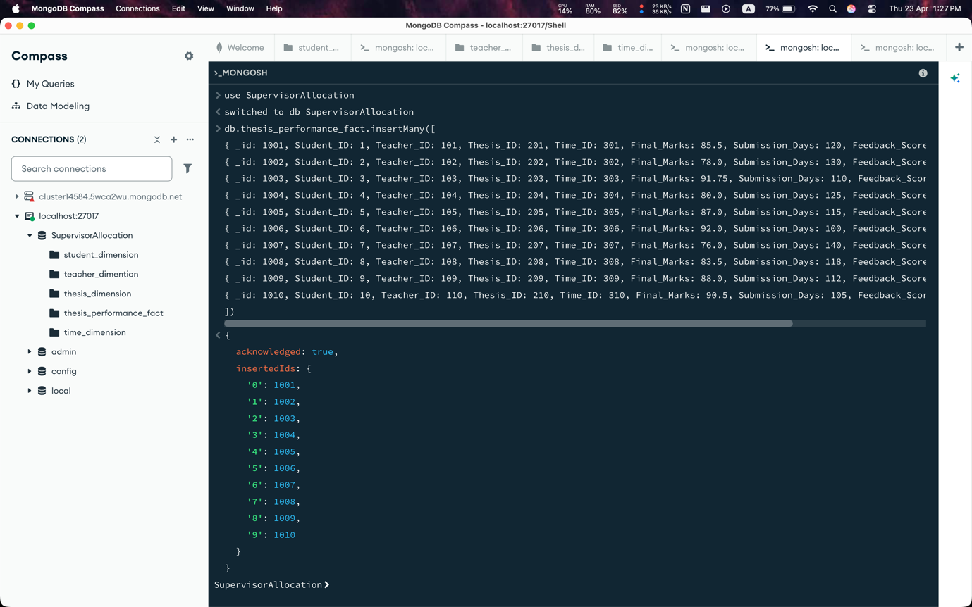

- Shows data

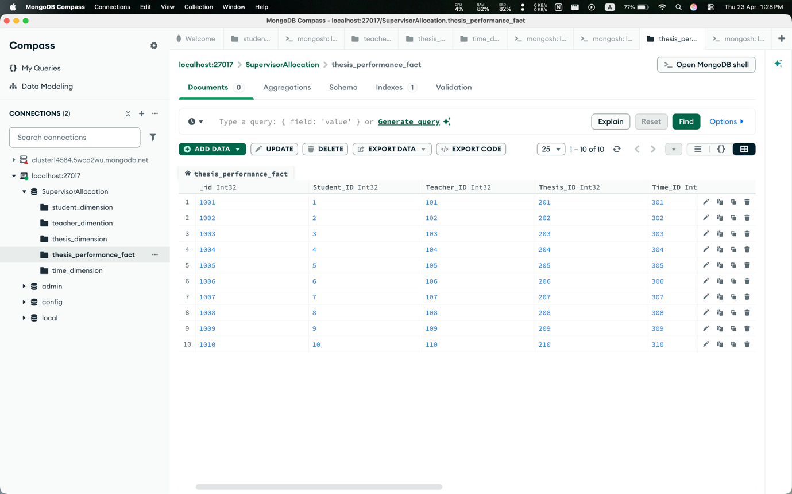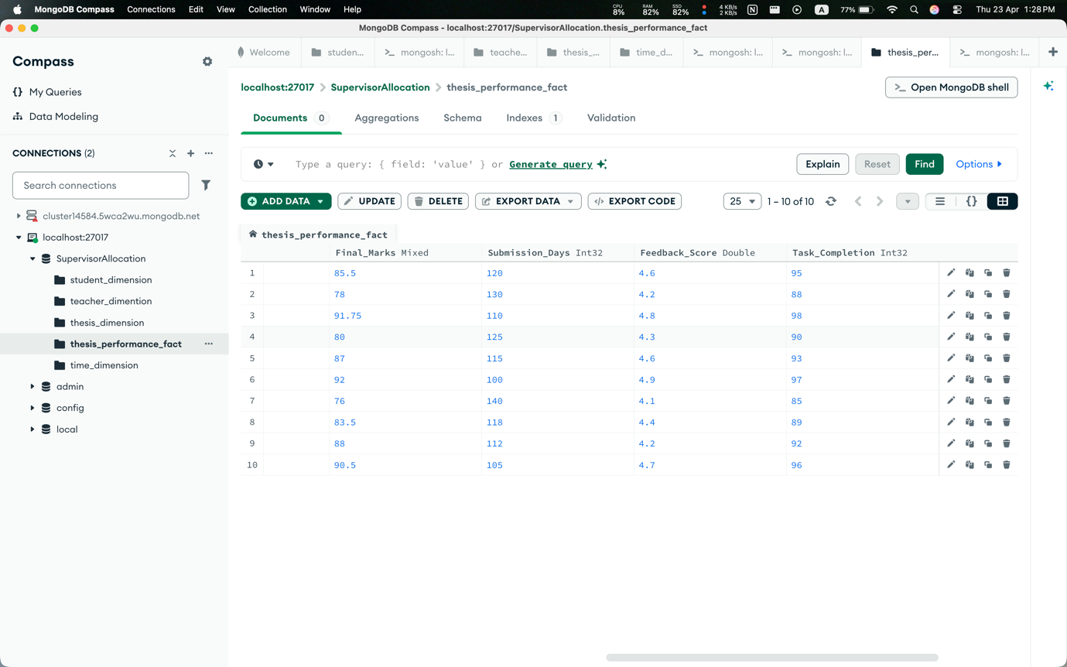

Dimension Table
- Creation

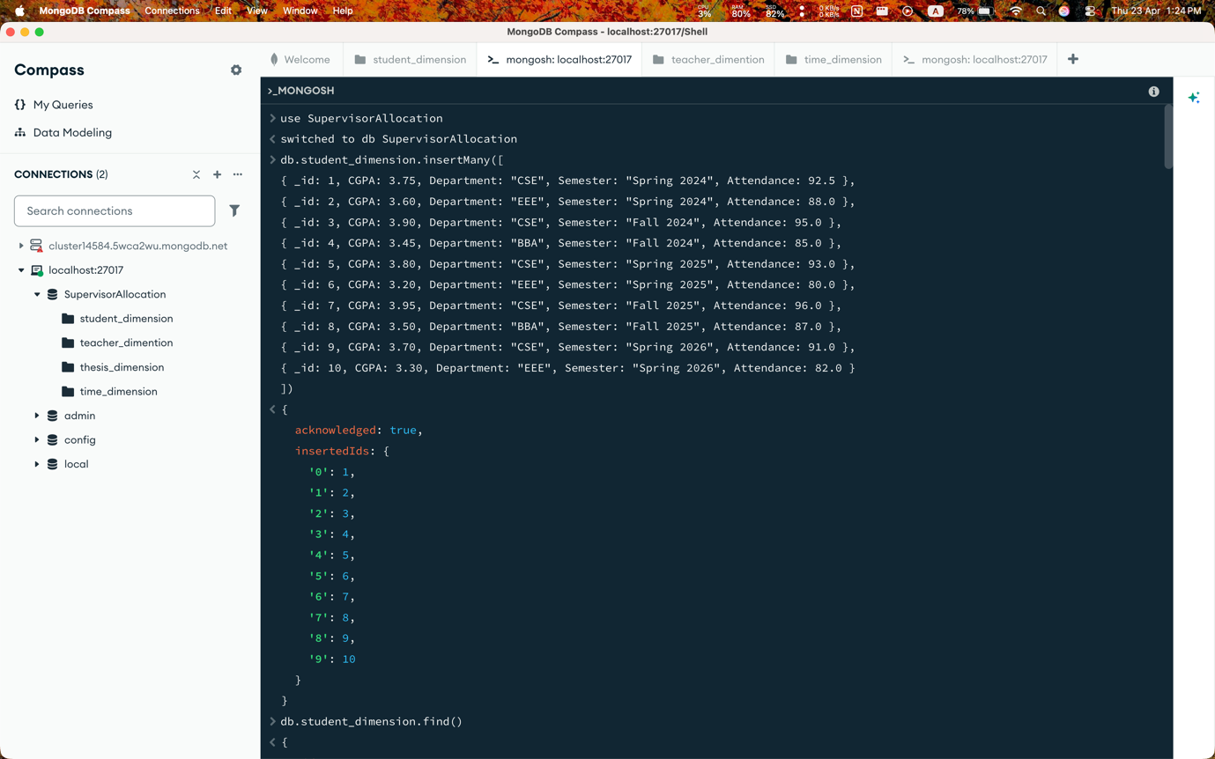
1.1 Student_dimension

1.2 Teacher_dimension

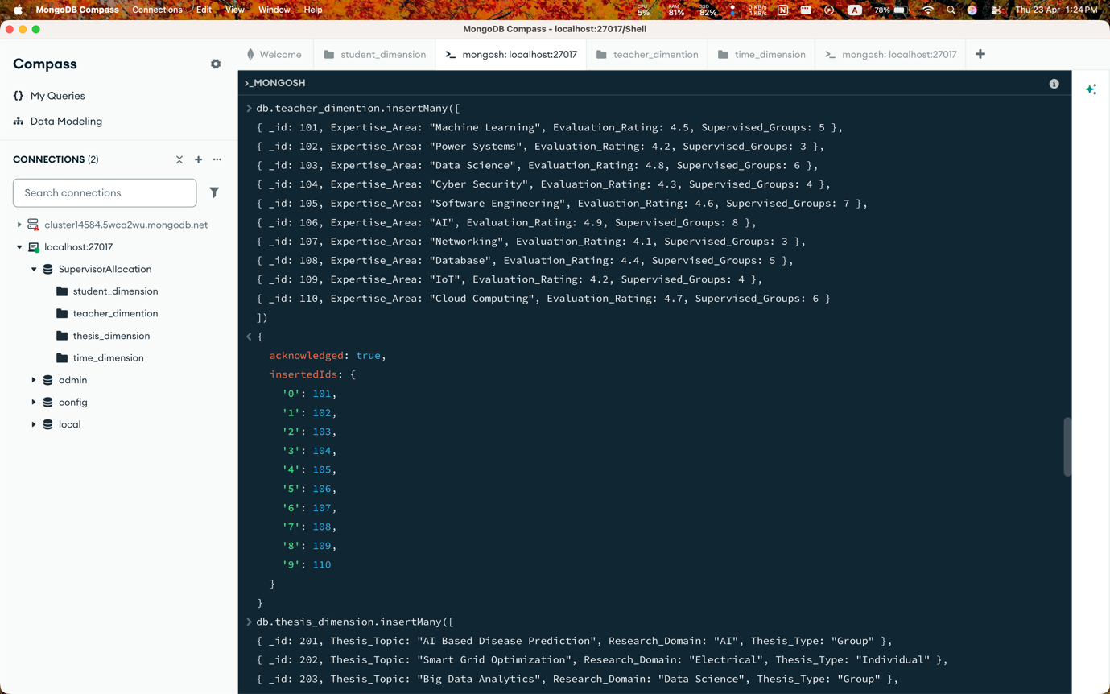

1.3 Thesis_dimension

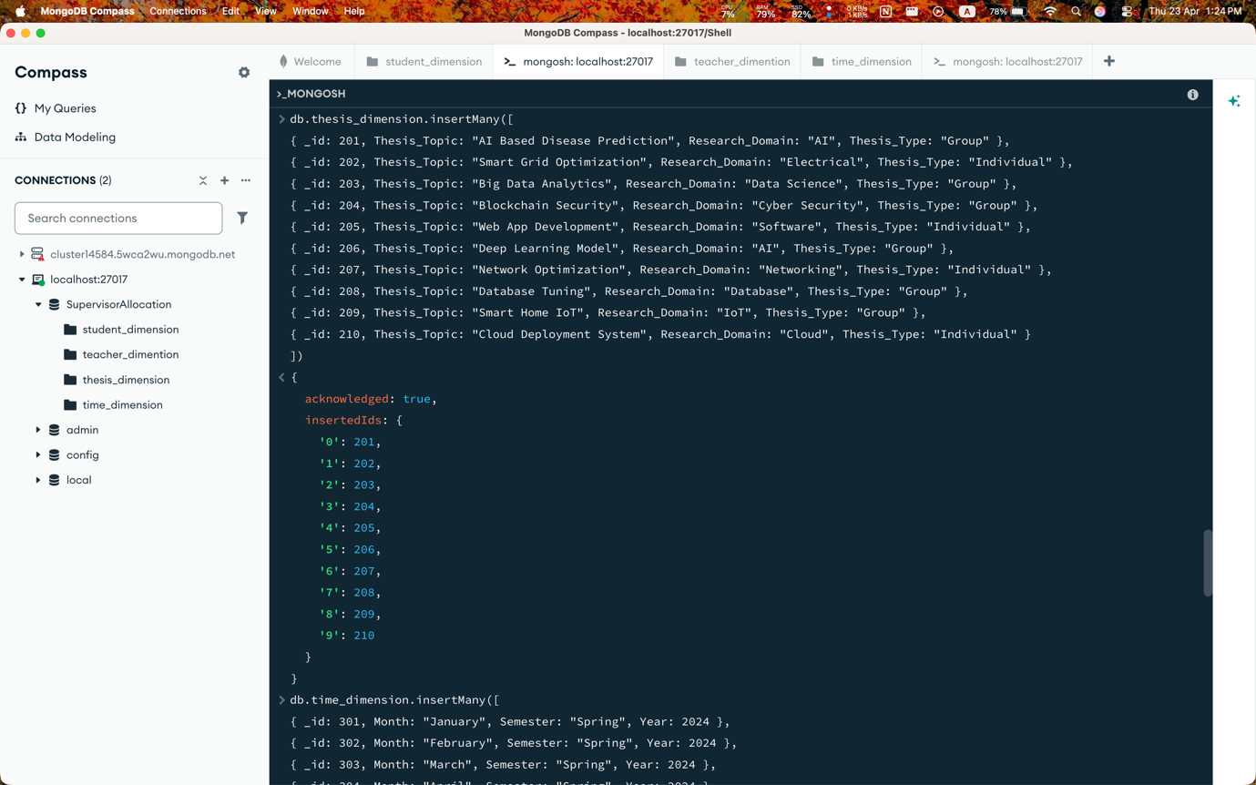

1.4 Time_dimension

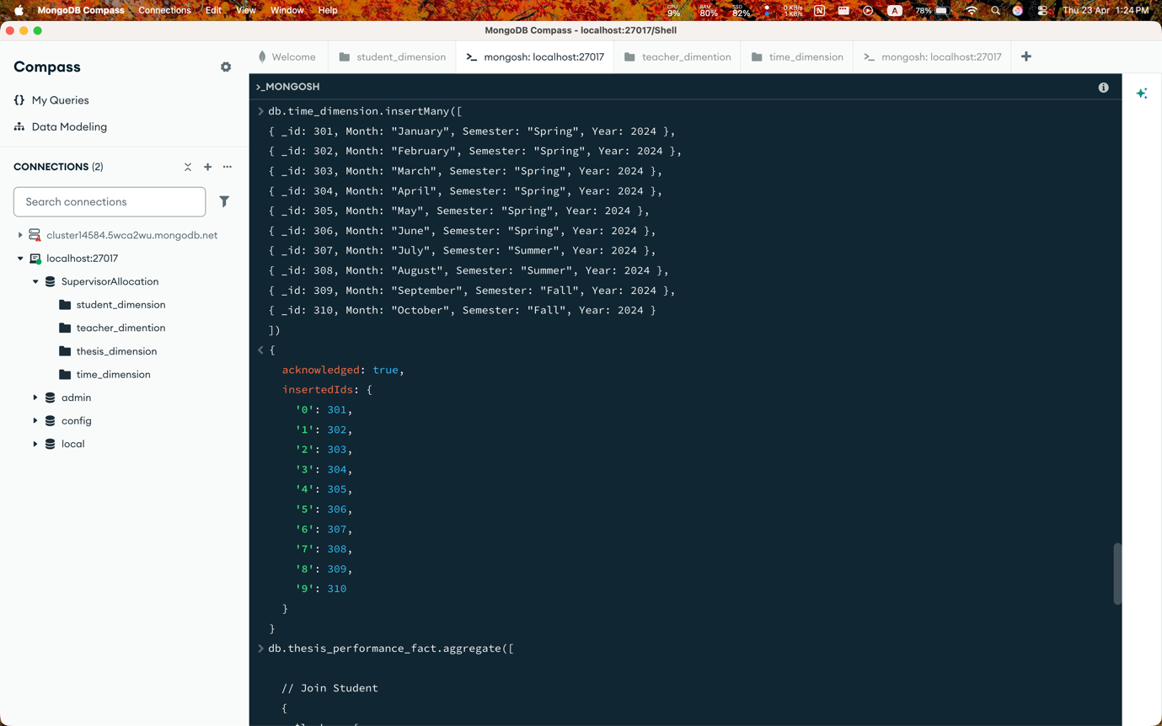
Show all dimension data:
  - Student_dimension Table

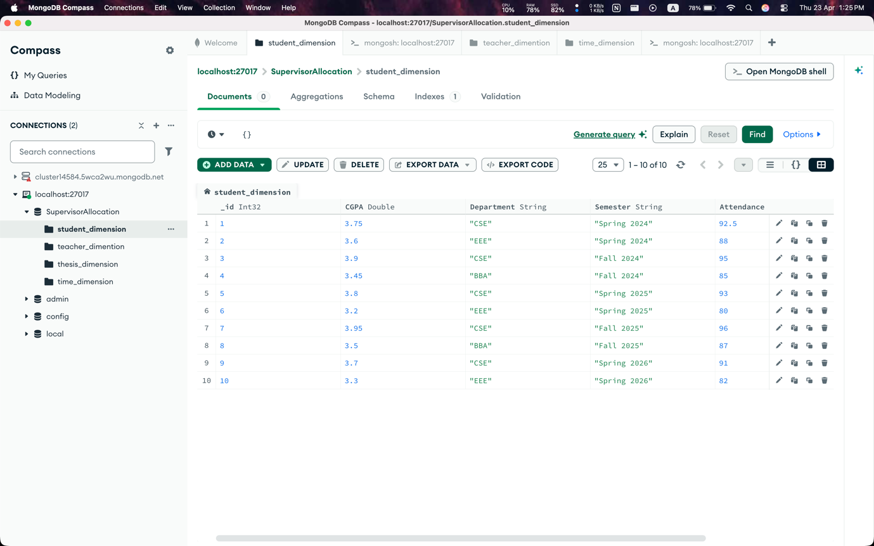

  - Teacher_dimension Table

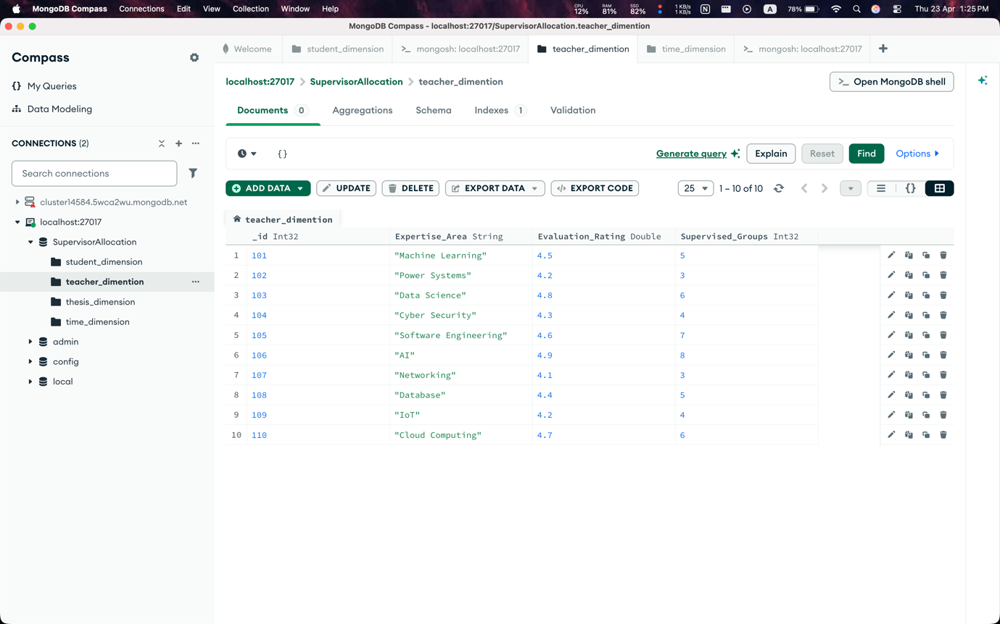

  - Thesis_dimension Table

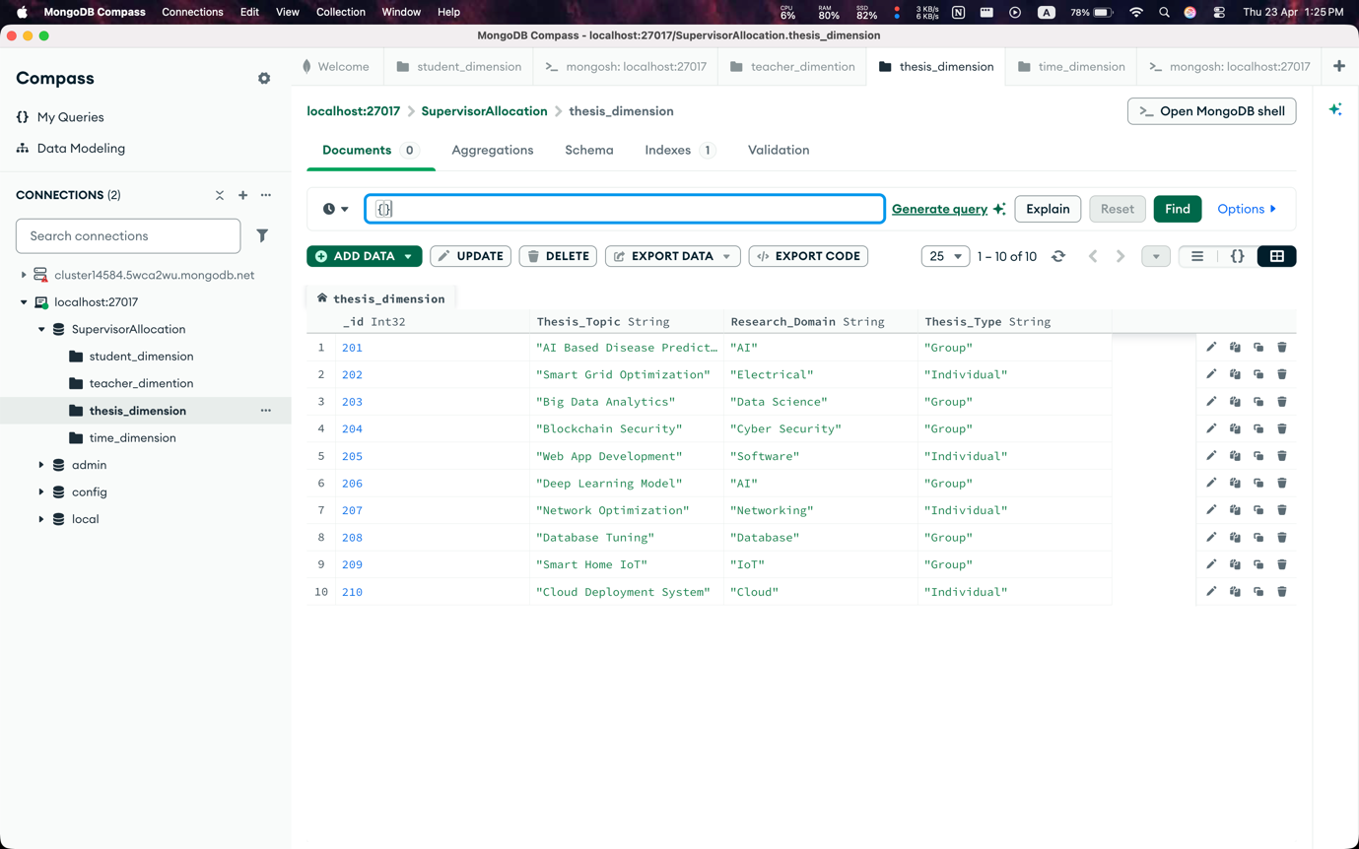

  - Time_dimension Table

